**Create Bullet Particles**

**Objective**: In this lesson, we're going to do an introduction to particle systems and we're going to use bullets as our example, so that we can create a bullet, laser beam system shooting out of our player ship.

1. First I created a platform under the rocket so I can see the changes easier without it blending into the environment.

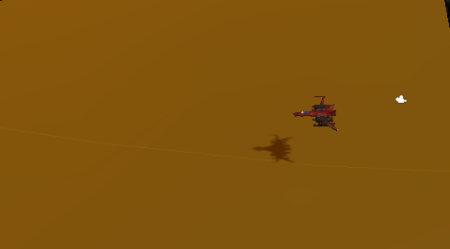

1. change the Terrains **Base Map Dist** to **2000** and turn **Cast Shadows On.** I've found these two haven't had a huge impact for me

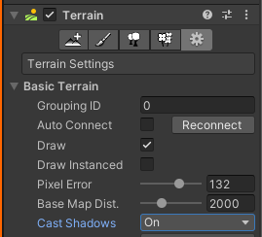

1. Right-click on the **Ship** and go to **Effects**>**Particle System**.

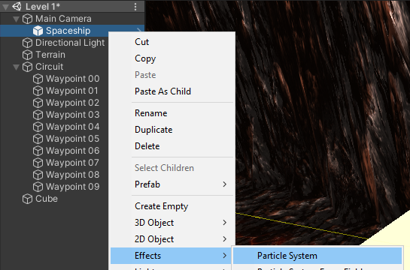

1. Rename particle system to **Laser**.
2. scroll all the way down in the inspector to **Renderer**, click on **Renderer** to expand that tab. we should see **Default Particle**.

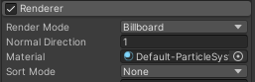

1. Now I'm going to give you guys an asset pack, which will have something called **Particle** **Materials**. Drag it on to the **Assets** folder and import all. You should now have a folder called **Particles.**

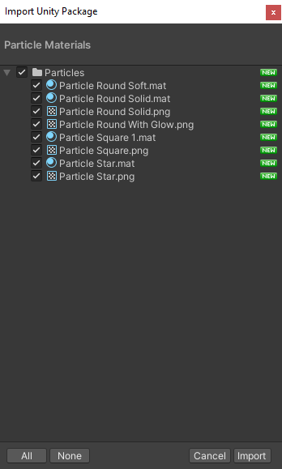

1. Now back in the **Renderer** tab I’m going to change the **Material** from **Default** to **Particle Square.** That immediately changes all these to square-looking particles.

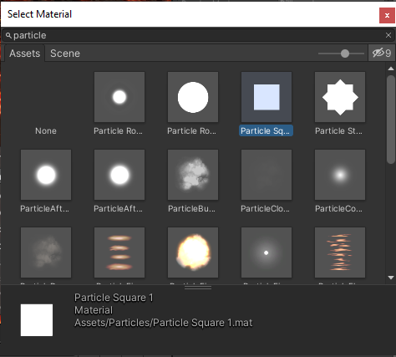

1. Find the **Shape** tab. Change the Shape to **Sphere.** We’re going to stick with the **Cone** shape
2. Reduce the **Angle** to **0**
3. Reduce the **Radius** to **0.01**

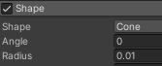

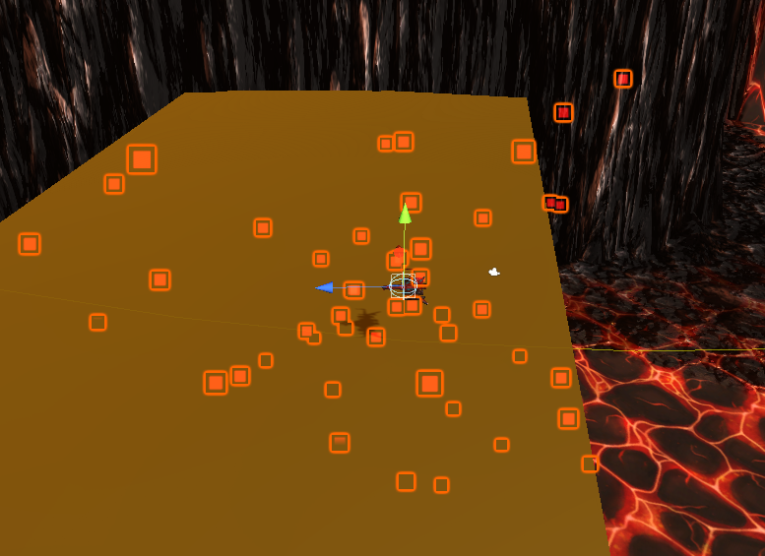

1. Lets go in game and test it out.

One of the immediate problems is we can't reach the **side of our screen here**.

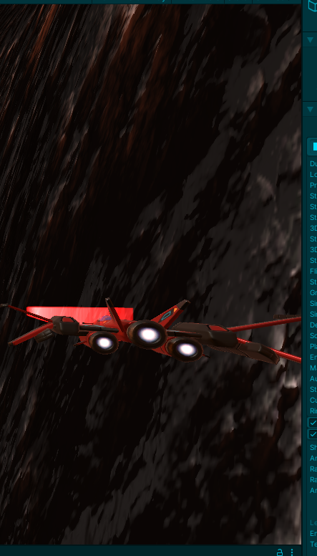

1. GO INTO PLAY MODE
2. Change Position Yaw Factor to 7
3. change **X Range to 8.**

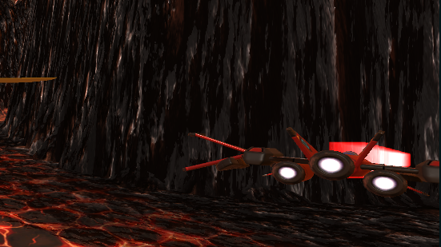

1. **turn off Looping** and click the PARTICLE EFFECT **Play button**, you'll see that **Duration** is **5**. That means we will emit particles and then after 5 seconds it stops.

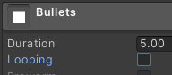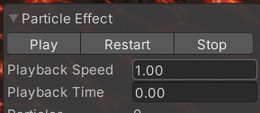

1. Change the **Duration** to **1 second** and click play, then we can see for one second it emits particles.

How many?

Well, it's emitting 10 particles the right amount of time here per second, duration is 1 second, it's emitting 10.

1. Inside the **Emission** tab lets change the **Rate Over Time** to **3**



For our bullets, we don't really need to have full 1 second of things being emitted. We want our system to say emit something, stop, emit something, stop, emit something.

1. turn the **Duration** down to **0.2**.
2. turn **Looping back on** so we can see the effect of changing things.

We can see each individual bullet flying out. And this is not going very far, why is that? Well, first of all, we've got the Start Lifetime of 5 seconds. So each of these is going last five seconds And then it will stop It'll be terminated and no longer be a particle. 

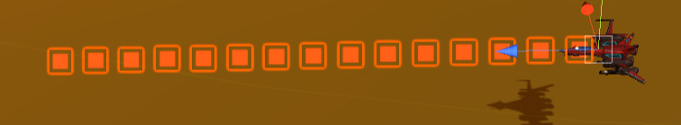

1.  increase the **Start Speed** to **10**, then you can see they still last for 5 seconds, but then they're going a lot further, because they're going faster.
2. reduce this **Start Lifetime down to 1**, they're only going last one second
3. increase **Start Speed to 50**, they're going a similar distance the way they were before, but they're going a lot faster to get to that same distance.
4. turn the **Lifetime** back up to **2 seconds**
5. increase the **Start Speed to 100**, so they're a bit more like, pew, pew, pew
6. Find the **Start Color** field, I'm going to make mine a pretty kind of blue. Choose whatever you think works.



1. change the **Simulation Space** from **local** to **World**



If we fly around at the moment, the particles are being childed to the ship and they're being told to respond in local space. So when the game is moving up and down, the entire particle system moves up and down. We changed this to world, then the bullets tend to keep going off where they were shot from.

1. Change the **Playback Speed** for the **Particle Effect to 0.25**

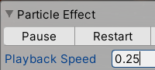

1. Find the **Trails** tab, make sure if you're selecting any of these new elements, you click on the **check box** next to it to activate it. We can see that trails being added and we've got the pink material that says, no material is attached.

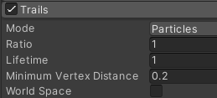

1. And to attach a material you'd think it'd be under trails, but it's under **Renderer**. A new area has appeared, **trail material**.

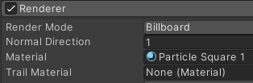

1. Let's click on that, I'm going to choose the same **Particle** **Square material**.

There's too many, the trial is lasting too long

1. under **Trails** change the **Lifetime**. I want the trail to last 0.02, may be 0.05.

Now I've got a little bit of a problem, because you can see that the bullet is coming out first and then the trail. Well, it needs to look more like a laser beam that a bullet with a trail behind it.

1. under **Trails** to **click off** the checkbox of **Size Affects Width**.
2. Scroll back up to our **particle system**, find the size of the **Start Size** of the particle change **to 0.01** which basically makes it invisible.

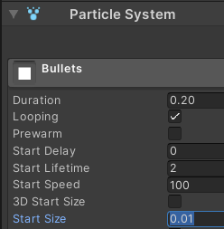

1. Find **Width over Trail** in the **Trails** tab I'd like to make this down to **0.3**, so it's more of a narrow kind of bullet.

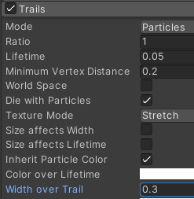

Let's have a look at how that looks when we fly around. Its looks more like a laser beam.

At the moment it looks like it's coming out a little bit too sparse, not being emitted enough

1. Go to the **Emissions** tab and turn my **rate over time** up to **10**